**SURVEY QUESTIONS**

1. Have you ever been in any emergency situation like road accident, natural calamity etc?

* Yes
* No

1. If yes, in which situation? (multiple answer question)

Road accident

Medical Emergency

Fire emergency

Natural calamity

Other

1. Were you able to call the hospital or any family member on your own in such situation?

* Yes
* No

1. Did you get the preliminary help required on time?

* Yes
* No

1. Have you ever helped anyone who has met with an accident?

* Yes
* No

1. In what way did you helped?
2. Are you currently using any application which provides help in emergency situations?

* Yes
* No

1. If yes, name that application.
2. According to you what should be the necessary features of such type of application?
3. Do you think that late arrival of help(e.g ambulance) can be a reason for death of people in case of accidents?

* Yes
* No

**SURVEY ANALYSIS**

Sample size of our survey is around 70 people. From which we got 50 responses. By looking at the survey results we have made certain observations and conclusions.

**1.Have you ever been in any emergency situation like road accident, natural calamity etc?**

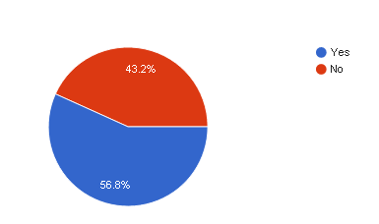

Around 56.8% of the people have been through an emergency situation. It means that most of the people have the idea about these types of situations and so they must be knowing what steps should be followed or what preliminary help is required at the time of emergency.

**2.If yes, in which situation?**

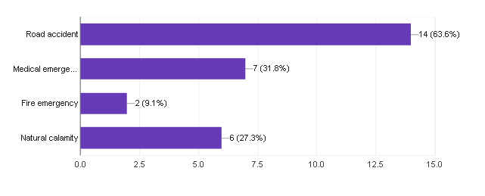

We have provided 4 options for this question which covered moly all possible emergency situations. Options are (1)Road Accident (2)Medical Emergency (3)Fire Emergency (4)Natural Calamity and other.

63.6% people have been through road accidents, 31.8% went through medical emergency, 9.1% went through fire emergency and 27.3% people went through different types of natural calamities.

Among the people who have responded, majority of them have been through road accidents which indicates that road accidents is major emergency situation around us. So by looking at this data we decided to build our software mainly for the road accident situation.

**3.Were you able to call the hospital or any family member on your own in such situation?**

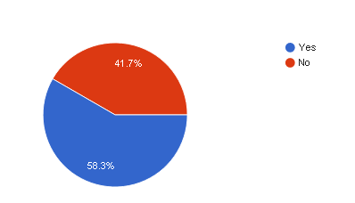

Almost 41.7% people were not able to contact family member or hospital for help in an emergency situation. There could be many reasons for this. Like person became unconscious in few minutes, person is not in condition to call someone, person doesn’t have contact number of nearby hospital or other emergency help service center.

**4.Did you get the preliminary help required on time?**

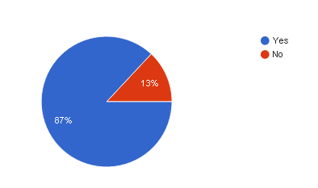

87% people said yes. That means that majority of the people got the preliminary help required on time. But we can’t ignore the remaining people. There is a need of such a system which provides preliminary help to the people in emergency situation. And the application should be such that the help is provided on time.

**5.Have you ever helped anyone who has met with an accident?**

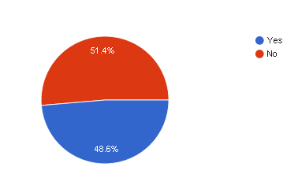

48.6% replied yes, which indicates many people helped other people who were getting through emergency situations. In order to help a person in any emergency condition one may require contact details of his/her family members and the contact number of the nearby hospital. Finding these contact numbers is not an easy task. This may take some time due to which condition of the person may become more critical.

**6.In what way did you helped?**

Most of the people helped victim of emergency situation by calling ambulance or providing them first aid.

**7.Are you currently using any application which provides help in emergency situations?**

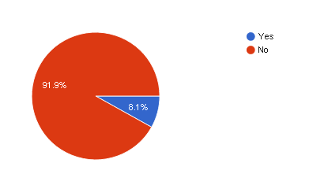

A large number of people that is 91.9% people are not using any application currently which provides help during emergency situation. We got this result because we took the survey of the students of DAIICT. And as most of the students live in the college itself, they do not use vehicles on daily basis. Natural calamities like tornado, hurricane, tsunami, earthquake, etc rarely affect Gujarat. In other emergency situations helps lines are already provided by government. So many people do not think emergency help service very important to them. But a emergency help service system would be very useful to other people and also to the people living in areas where natural calamities occur frequently. Other reason for not using any system may be that no system is that good enough. Maybe the existing system does not have all the features which an emergency help system should have.

**8.If yes, name that application.**

ICE-In Case of Emergency

**9.According to you what should be the necessary features of such type of application?**

According to the people the application required in case of emergency situations should be such that it is able to provide help or rescue the user in minimum amount of time. The application should be easily accessible by the user at the time of emergency. So for that the application should be activated by just clicking any special button on the home screen or anything else which activates the application quickly. After activating the application an emergency call or automatic instant SMS should be sent to the nearby hospital and to the family members. The application should be able to detect user’s location via GPS system and send this location to the hospital and family members so that help can be provided immediately. The response time that is the time the application takes to search for the nearby hospital, then informing the hospital and family members and to capture other information should be as minimum as possible. Also the services provided by this application should be available everywhere and at all the times.

**USER REQUIREMENTS**

1. The application should be easy to use so that everyone can get benefit of it.
2. The application should be able to provide help in as much situations as possible like road accidents, fire emergency or any other emergency condition.
3. According to the user the application which provides help in emergency situations should be activated quickly like on single click on home screen or by any other option.
4. The application should be able to make an automatic emergency call after it is activated.
5. The application should be able to send an automatic instant message after it is activated.
6. The emergency calls made or emergency messages sent should be able to work when there is no balance in the user’s phone.
7. The call or message should be made to the family members and to the nearby hospitals for fast rescue.
8. For fast dialing the application should store the contact number of the family members saved as emergency contact list. So the call can be made instantly to these numbers instead of wasting time searching the general contact list of the phone.
9. The application should be efficient enough to search for the nearby hospital or police station etc in minimum amount of time.
10. The application after activating should immediately start tracking the location of the user.
11. If the GPS of the mobile phone is off, the application should have the ability to turn the GPS on.
12. The location captured by the GPS should be sent to the emergency contact list and to the nearby hospitals.
13. The application after activating should also be able to capture the photos via front and back camera both, video recording and audio recording.
14. The photo or video recorded should be stored in the application for future references.
15. Collaborate with the insurance companies to provide insurance to the users. So for that an insurance report can be generated by using the photos and video recordings.
16. It should not be necessary that the person receiving an emergency call or message have that application installed in their phones.
17. The application should store the other useful information of the user as well. For example the application can save blood group of the user, past medical emergencies etc.
18. The application after it is activated should start a buzzer or something so that other people nearby to the user may know that the person is in need. This is a useful feature during medical emergencies like heart attack etc.
19. The services provided by this application should be available everywhere and at all the times.
20. The overall response time of the application should be as low as possible.

**USER CATEGORY:**

Our system is a general application which will work same for all the users. So as such there are no user categories. Only the general user is there.

**INTERVIEW PLAN:**

System : Emergency Service Project

Participants: Ekta

Date: 22/1/2018

Time : 7:00 PM

Duration : 20 minutes

Place: Hostel

Purpose of Interview :To know why people are not using existing available emergency help application

Agenda : Problems in existing emergency help application

**INTERVIEW SUMMARY**

System : Emergency Service Project

Participants: Ekta

Date: 22/1/2018

Time : 7:00 PM

Duration : 20 minutes

Place: Hostel

Purpose of Interview :To know why people are not using existing available emergency help application

1.Do not use vehicles on daily basis so very rare chance of road accidents.

2.Natural calamities is not rarely happening event.Besides earthquake hurricane, tornado, tsunami,volcano eruption is not problem in gujarat state, so no need for emergency help application which helps in such situation.

3.Many existing emergency help service does not provide location of nearby hospitals.

4. Many existing emergency help service can not send SMS or call on zero balance.

5. Many existing emergency help service do not have feature of storing priore medical information of user.

6. Many existing applications are good, but they provides service in limited area or only in some cities.

**INTERVIEW PLAN:**

System : Emergency Service Project

Participants: Shiwangi

Date: 22/1/2018

Time : 9:00 PM

Duration : 25 minutes

Place: Hostel

Purpose of Interview :To get to know about existing emergency help service application

And how this application works.

Agenda : Features of an existing emergency help application

**INTERVIEW SUMMARY**

System : Emergency Service Project

Participants: Shiwangi

Date: 22/1/2018

Time : 9:00 PM

Duration : 20 minutes

Place: Hostel

Purpose of Interview :To get to know about existing emergency help service application

And how this application works.

Application : ICE- In Case of Emergency

1. ICE application stores data which can be helpful by rescuers and doctors in case of emergency. Stored data is about passed medical disease, allergies, and other important health information.

2. This application let create multiple profiles, so it can stores information about family members or other close people.

3. In case of emergency by pressing one alarm button this application will send critical situation message and GPS location of user to emergency contact list of user.

4. Especially when user is far away from home and in case of emergency, user need fast help then this kind of application is very useful.

5. Emergency situation is rarely occurring event, so person do not know to how to handle situation and whom to ask for help, in this kind of situation this application is very helpful.

6. Even if very rare possibility of user will get into critical situation, it is very helpful to have such emergency help application downloaded in your smart device.

7. ICE is very useful application but it do not have option like if any one want to use this application for other people. If you want to call nearby hospital or help center then it is not provided by application.